How Security Is Achieved Using OCI Certificates in the Cloud

Abstract
In modern cloud environments, ensuring secure communication, authentication, and trust management is essential. Oracle Cloud Infrastructure (OCI) provides a managed Certificates service that simplifies certificate creation, renewal, and lifecycle management while integrating tightly with other OCI services. This white paper explores how OCI Certificates strengthen cloud security across external, internal, and hybrid workloads. It explains how managed PKI underpins authentication, encryption, and data integrity, highlighting real-world scenarios that humanize how trust is achieved in the cloud.

1. Introduction
Security in cloud computing hinges on trust - knowing that the systems and entities we communicate with are authentic, and that the data exchanged is protected. Certificates, backed by public key infrastructure (PKI), are the digital credentials that enable this trust. OCI Certificates offers a managed service to create, issue, renew, and revoke certificates for securing workloads and communications within Oracle Cloud Infrastructure [1].
By integrating certificate management into the cloud control plane, OCI eliminates manual renewal errors, enforces key security standards, and allows scalable trust across virtual machines, load balancers, and APIs. This is vital in dynamic environments where microservices and APIs spin up and down constantly.

2. Foundations of Trust: OCI Certificate Architecture
The foundation of OCI certificate-based security lies in a hierarchical trust model, composed of three layers:
- Root Certificate Authority (CA):
The highest trust anchor, often protected by a hardware security module (HSM) through OCI Vault [1].
- Subordinate (Intermediate) CA:
Used to issue end-entity certificates without exposing the root key.
- End-Entity Certificates:
Used by servers, clients, and workloads for TLS or mutual TLS (mTLS) authentication.
The OCI Certificates service allows users to create both root and subordinate CAs, generate end-entity certificates, and manage revocation lists (CRLs). This structure ensures that even if one key is compromised, the trust chain remains intact.

Figure 1: OCI Certificate-Based Security Workflow

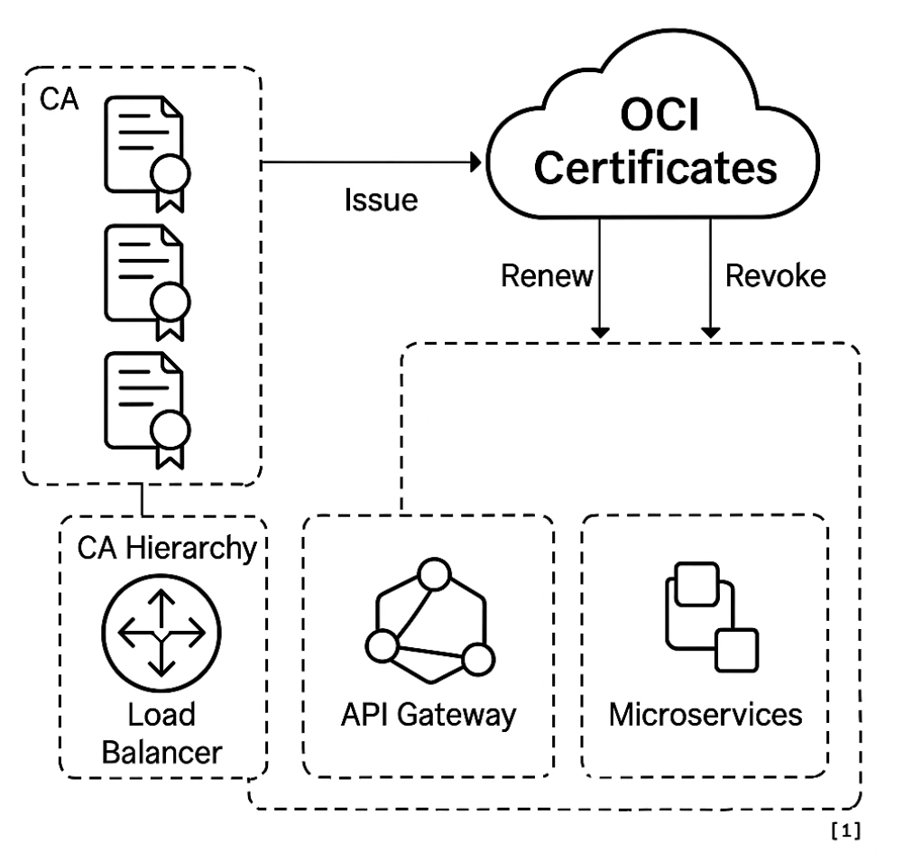
(Figure 1, showing OCI Certificates issuing, renewing, and revoking certificates across load balancers, API gateways, and microservices, all linked to a secure CA hierarchy.)

3. Certificate Lifecycle and Automation
Security doesn’t end with certificate issuance—it depends on continuous lifecycle management.

3.1 Automated Renewal
OCI supports automated certificate renewal and notifications before expiry. This prevents service outages caused by expired certificates, one of the most common causes of unplanned downtime [2].

3.2 Integration with OCI Services
OCI Certificates integrates directly with Load Balancer, API Gateway, and Service Mesh. This allows administrators to attach certificates to front-end or internal services seamlessly. For example:
- A Load Balancer can automatically rotate its TLS certificate when renewed in OCI Certificates.
- The API Gateway uses certificates to authenticate client requests.
- In Service Mesh, mTLS ensures that each microservice validates its peer before communication.

3.3 Revocation and Monitoring
OCI’s certificate revocation process ensures that compromised or invalid certificates can be promptly removed from the trust chain. All operations are tracked through OCI Audit Logs, offering compliance visibility.

3.4 Integration with Vault
By coupling the Certificates service with OCI Vault, private keys are stored in a hardware-protected HSM. This prevents extraction of private material and aligns with compliance frameworks like FIPS 140-2.

4. Use Cases
OCI Certificates enable secure operations across multiple cloud scenarios.

4.1 External Web Applications
For public-facing websites, OCI Certificates issue and automatically renew SSL/TLS certificates bound to load balancers or custom domains. This eliminates manual certificate handling and ensures browser trust through chain validation.

4.2 Internal Microservices
Microservice architectures rely on high-frequency communication between workloads. With mTLS certificates issued from an internal CA, each service proves its identity before exchanging data. This enforces zero-trust principles - no implicit trust between services, even within the same network [2].

4.3 Hybrid and Multi-Cloud Connectivity
When extending workloads to on-premises or other cloud environments (via FastConnect or VPN), certificates provide cross-cloud trust. Organizations can import their existing internal CA certificates into OCI or use OCI Certificates to manage hybrid trust boundaries [1].

5. Security Benefits
Certificates form the basis of multiple security guarantees in OCI:
Security Objective | Achieved Through | Benefit
Authentication | Certificates verify workload, service, or client identity. | Prevents impersonation attacks.
Confidentiality | TLS/mTLS encrypts in-transit data. | Protects sensitive data exchanges.
Integrity | Digital signatures on data and code. | Ensures tamper-proof communication.
Non-repudiation | Key pairs uniquely identify actions. | Provides auditability and accountability.
Governance | IAM and Audit integrate with certificate operations. | Centralized control and compliance readiness

6. Design Best Practices
OCI recommends several operational best practices for certificate-driven security:
- Short-Lived Certificates: Use limited validity periods (e.g., 90 days) to reduce exposure risk if a key is compromised.
- Strong Cryptography: Prefer modern algorithms like RSA 4096 or ECDSA P-384.
- Automate Renewals: Enable automatic renewals through OCI Certificates to avoid outages.
- Use Vault for Key Storage: Always protect root and subordinate CA private keys with OCI Vault.
- Compartmentalize CAs: Create separate compartments for production and development CAs.
- Audit and Monitor: Enable OCI Audit service to log every certificate event.
- Integrate with Service Mesh: Use mTLS certificates for internal authentication between microservices.
- Tag Certificates: Use resource tags to track certificate owners and environments.
Following these practices ensures predictable, auditable, and scalable security operations.

7. Challenges and Limitations
While OCI Certificates simplify PKI management, organizations should remain aware of operational caveats:
- Mis-Issued Certificates: Inadequate access controls can result in unauthorized issuance. Implement strong IAM policies.
- Revocation Latency: There may be short delays between revocation and propagation.
- Algorithm Obsolescence: Periodically migrate certificates to stronger algorithms as cryptographic standards evolve.
- Multi-Cloud Trust Alignment: Public CAs may not automatically integrate with all non-Oracle environments—plan for certificate import/export processes.
Despite these challenges, OCI Certificates significantly reduce complexity by making PKI an integrated, managed component of the cloud platform.

8. Future Directions
Oracle continues to enhance certificate-based security capabilities with:
- Post-Quantum Cryptography (PQC): Future support for quantum-resistant algorithms.
- Expanded API Support: For external certificate lifecycle automation via REST APIs.
- Deep Observability: Integration with OCI Logging and Cloud Guard for certificate misuse detection.
- Federated Trust Models: Allowing secure certificate federation across multiple tenancies.
These advances will help organizations future-proof their cloud security against evolving threats.

9. Conclusion
OCI Certificates transform how trust and encryption are managed in the cloud. By offering automated certificate lifecycle management, secure key storage, and native integration with critical services, OCI simplifies PKI operations without sacrificing security. Organizations gain the assurance that all communications—whether between external users or internal workloads—are authenticated, encrypted, and monitored.
Security is no longer an afterthought but an embedded, automated component of every OCI resource. Adopting certificate-driven trust not only strengthens defense but also operational resilience.

References
[1] Oracle Cloud Infrastructure Documentation — Overview of Certificates.
https://docs.oracle.com/en-us/iaas/Content/certificates/overview.htm
[2] Oracle Cloud Infrastructure Documentation — Creating and Managing Certificates.
https://docs.oracle.com/en-us/iaas/Content/certificates/creating-certificate.htm

