Data Sovereignty and Compliance in Multi-Cloud Government Platforms

Abstract
The growing reliance on multi-cloud environments has transformed how governments manage, process, and secure sensitive data. However, as agencies adopt diverse cloud infrastructures—often spanning multiple jurisdictions—they face significant challenges in ensuring compliance with data sovereignty, privacy, and regulatory mandates. This white paper explores the architectural, operational, and legal dimensions of data sovereignty in multi-cloud government platforms, emphasizing strategies for secure data residency, unified compliance enforcement, and zero-trust governance. The analysis draws upon best practices in cloud security and regulatory alignment, offering a framework to ensure that government data remains sovereign, compliant, and resilient across cloud boundaries.

1. Introduction
Government agencies worldwide are rapidly transitioning to cloud-first and multi-cloud models to improve scalability, agility, and digital service delivery. Yet, unlike commercial enterprises, public-sector organizations handle data that is legally bound to geographic and jurisdictional constraints. Regulations such as the EU’s General Data Protection Regulation (GDPR) [1], the U.S. Federal Risk and Authorization Management Program (FedRAMP), and sovereign cloud initiatives in regions such as the EU, India, and the Middle East impose strict mandates on where and how data can be stored, processed, and transmitted.
Multi-cloud architectures—where services are distributed across multiple cloud providers such as AWS, Azure, Oracle Cloud, or Google Cloud—introduce both opportunities and complexities. While they provide flexibility, resilience, and vendor independence, they also fragment compliance responsibilities and data control mechanisms. This fragmentation heightens the risk of data leakage across jurisdictions, inconsistent policy enforcement, and regulatory violations.
This paper examines these challenges and proposes a sovereign-by-design approach—a combination of policy, architecture, and technology—to ensure compliance and control within multi-cloud government platforms.

2. The Challenge of Data Sovereignty in Multi-Cloud Environments
Data sovereignty refers to the principle that data is subject to the laws of the nation in which it is collected or stored. For governments, this concept is not just a compliance concern but also a matter of national security and citizen trust. When data traverses multiple cloud regions—often operated by global providers—sovereignty risks increase dramatically.

2.1 Jurisdictional Complexity
Different nations define “sovereign data” differently. For instance, the European Union demands that citizen data not leave EU borders unless equivalent protections exist [1]. Similarly, India’s Data Protection Act mandates local data storage for certain categories. In contrast, U.S. agencies must adhere to FedRAMP and the Federal Information Security Management Act (FISMA), which impose stringent access and audit controls.
Multi-cloud platforms often host workloads across these jurisdictions, making cross-border data-flow governance an operational and legal challenge.

2.2 Fragmented Security and Compliance Controls
Each cloud provider maintains its own security and compliance frameworks. While providers may comply with ISO 27001 or SOC 2, the lack of standardized enforcement across platforms makes unified compliance auditing difficult. For example, an agency might use AWS GovCloud for critical workloads while deploying analytics pipelines on Azure Government Cloud. Without centralized control and visibility, data lineage and compliance tracking become inconsistent.

2.3 Risk of Shadow Data Movement
APIs, replication services, and global load balancers can inadvertently replicate sensitive datasets across regions for performance or backup purposes. These automatic operations—often enabled by default—can violate sovereignty policies. Thus, even technically secure systems can become legally non-compliant if data placement and residency rules are not explicitly enforced.

3. Architectural Principles for Sovereign Multi-Cloud Design
To navigate these challenges, government IT architects must adopt a sovereign-by-design approach—embedding sovereignty and compliance into the architecture rather than retrofitting them later.

3.1 Zero-Trust Governance
Zero Trust assumes that no user, workload, or service is inherently trusted—inside or outside the network [2]. Applying this model in multi-cloud environments ensures that data-access policies, encryption keys, and identity assertions are centrally controlled and verified before any operation.
- Identity Federation: Enforce Single Sign-On (SSO) using sovereign identity providers.
- Continuous Verification: Monitor data-access patterns across all clouds.
- Policy Enforcement Points: Deploy distributed control planes that evaluate compliance rules before granting data access.

3.2 Unified Compliance Control Plane
Governments must implement a cross-cloud compliance orchestration layer capable of applying uniform policies across providers. This can be achieved using:
- Policy-as-Code frameworks (e.g., Open Policy Agent) for consistent enforcement.
- Multi-cloud configuration baselines (e.g., CIS or NIST 800-53) for shared compliance templates [2].
- Automated evidence collection for audits and continuous authorization.
This centralized layer should provide real-time compliance visibility, enabling continuous monitoring rather than periodic certification.

3.3 Data Residency and Encryption Boundaries
Encryption remains the cornerstone of sovereign data protection. However, governments should control not only encryption algorithms but also key-management locations.
- Regional Key Management Services (KMS): Ensure that cryptographic keys never leave sovereign regions.
- Customer-Managed Keys (CMK): Retain ultimate control over decryption rights, even when using third-party infrastructure.
- Data Localization Controls: Prevent replication of sensitive datasets beyond approved zones using provider APIs and object-storage policies.

3.4 Federated Monitoring and Auditability
Auditing sovereign data across multi-cloud systems demands federated observability - a unified view of logs, metrics, and traces without compromising data location. Using tools such as OpenTelemetry and sovereign SIEM systems, governments can monitor compliance violations without aggregating logs into non-sovereign regions.

4. Implementation Roadmap
A practical roadmap for adopting data sovereignty in multi-cloud government platforms should proceed in stages:
- Assessment: Inventory all data assets and classify them based on sensitivity and legal jurisdiction.
- Segmentation: Map workloads to compliant cloud regions and providers.
- Policy Definition: Codify compliance mandates using policy-as-code and infrastructure-as-code templates.
- Control Plane Deployment: Establish a cross-cloud governance layer with centralized identity, encryption, and audit management.
- Continuous Validation: Integrate compliance scanning and automated policy enforcement pipelines into DevSecOps workflows.
- Periodic Review: Conduct sovereignty audits using both technical and legal teams to adapt to evolving regulations.
This roadmap aligns with frameworks such as NIST SP 800-207 (Zero Trust Architecture) [2] and CIS Benchmarks, allowing incremental modernization while ensuring legal compliance.

5. Case Example: A Federal Multi-Cloud Data Exchange
Consider a federal agency that operates a data exchange connecting public safety, healthcare, and citizen-identity systems. The platform uses a combination of compliant government cloud regions across multiple providers.
By implementing a Sovereign Control Plane, the agency enforces:
- Unified identity and key management within national boundaries.
- Policy-as-code rules restricting replication beyond approved regions.
- Continuous FedRAMP-compliant monitoring and automated compliance reports.
The result is a system where data remains sovereign and auditable, even as workloads move dynamically across clouds - demonstrating the feasibility of secure, compliant, multi-cloud operations for government use.

6. Figure 1: Sovereign Multi-Cloud Control Plane Architecture
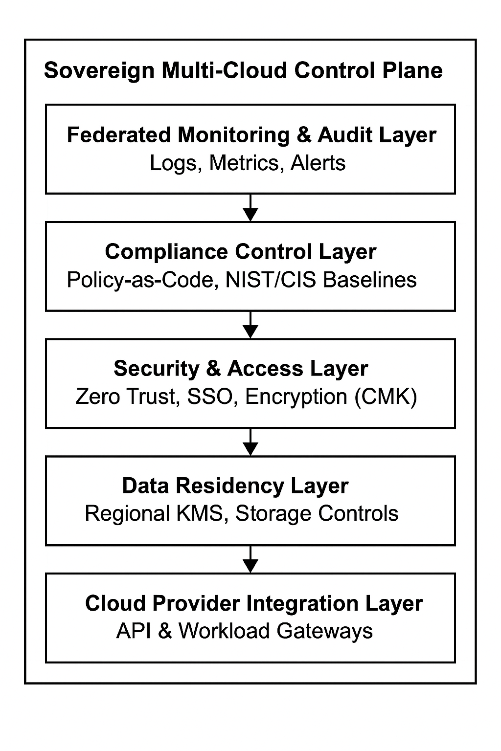
Figure 1 illustrates a sovereign control plane spanning multiple cloud environments.
It enforces zero-trust policies [2], unified compliance [1], and data-localization boundaries
across all provider integrations.

7. Discussion
Data sovereignty is no longer a compliance checkbox - it is a strategic pillar of national resilience. As geopolitical tensions and cyber threats escalate, control over government data has become as vital as control over critical infrastructure. The convergence of Zero Trust principles [2], automation, and federated compliance frameworks [1] provides a viable path forward.
However, sovereignty enforcement is not purely technical; it also demands policy modernization and public-private collaboration. Cloud providers must support transparency, open standards, and local control options, while governments must build legal frameworks that balance innovation with protectionism.

8. Conclusion
Multi-cloud government platforms represent the future of digital governance - flexible, scalable, and collaborative. Yet, this transformation must be anchored in the principles of data sovereignty, legal compliance, and operational transparency. By integrating sovereignty controls into architecture - through zero trust [2], policy automation, and federated monitoring [1] - governments can achieve both innovation and compliance. The future of digital governance will depend on how effectively nations can assert control over their data without isolating themselves from global technological ecosystems.

References
[1] European Union, General Data Protection Regulation (GDPR), 2018.
[2] National Institute of Standards and Technology (NIST), Special Publication 800-207: Zero Trust Architecture, 2020.

