Conversational Data Access: Natural Language to SQL in Enterprise Systems

Abstract
Conversational data access allows business users to query enterprise data using natural language instead of SQL. This whitepaper explains how organizations can implement NL-to-SQL systems, the underlying architecture, common patterns, risks, and governance controls required to deploy them safely and effectively.

1. Introduction
Enterprises heavily rely on SQL for analytics, yet most business users cannot write SQL queries. Conversational interfaces enabled by LLMs offer a bridge by translating natural language into SQL queries and then to analytics. This democratizes data access, accelerates decision making, and reduces bottlenecks on data engineering teams.

2. What Is Natural Language to SQL?
Natural Language to SQL (NL-to-SQL) allows users to ask questions like “Show top 10 products by sales last quarter” and receive correct, governed SQL queries automatically.
It uses semantic models, metadata, and LLM reasoning to ensure accuracy and compliance.
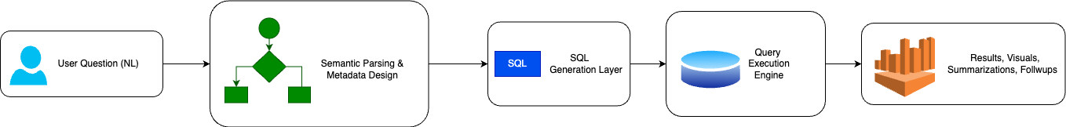
Figure 1: High-Level NL-to-SQL Workflow

3. Architecture of Enterprise NL-to-SQL Systems
A complete conversational data system includes:
- Semantic Layer
- Metadata Catalog
- Query Understanding Engine
- SQL Generator
- Policy Enforcement Layer
- Execution Engine
- Response Formatter
This architecture ensures that responses are accurate, governed, and explainable.
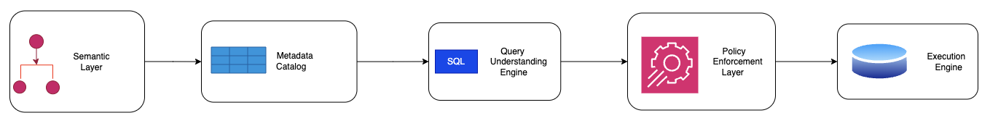
Figure 2: NL-to-SQL System Architecture

4. Key Patterns for NL-to-SQL
Enterprise patterns include:
- Semantic first interpretation
- SQL template grounding
- Metadata-governed query generation
- Join path inference
- Column-level security enforcement
These patterns increase correctness and reliability.

5. Common Challenges
General Challenges include:
- Allowing LLMs full creative SQL freedom
- Lack of semantic grounding
- No lineage tracking
- Using untrusted datasets
- Skipping policy enforcement
Avoiding these ensures accuracy and trustworthiness.
Creative SQL Freedom

Lack of Semantic Grounding

Untrusted Datasets

Skipping Policy Enforcement

Figure 3: NL-to-SQL Challenges

6. Governance for Conversational Data Access
Governance requires:
- Role-based access
- Data masking
- Query validation
- Prompt-level restrictions
- Logging and audit trails
- Transparent reasoning
These protections prevent data leakage and incorrect insights.

7. Practical Use Cases
Use cases include:
- Self-service analytics
- Executive Q&A
- Operational dashboards on demand
- Customer support intelligence
- Finance and compliance queries
NL-to-SQL unlocks insights for every business unit.

8. Implementation Roadmap
Implementation progresses through:
- Data readiness assessment
- Semantic model development
- Governance integration
- NL-to-SQL model deployment
- Feedback loop and continuous improvement
This roadmap ensures scalable and safe adoption.

9. Conclusion
Conversational data access modernizes enterprise analytics by merging BI, semantics, and GenAI. With proper governance, NL-to-SQL systems empower non-technical users while maintaining trust, consistency, and security.

